Guided Study Aid
(Use one guide per course per concept/skill/learning outcome per study session.)
Your name: ___________________________ Today’s date: _________________
Your course: _____________________________
Planned amount of time for this material: _______________
Plan your work
This is the concept, skill, or course learning outcome I will focus on:
I’ll use the following resources:
Librarian | Student Success Staff | Research resources/books
Peer Mentor | Peer Tutor | Study group
My own textbook & materials | Workshop/Success Social | Other

I will know I’ve been successful because I will be able to:
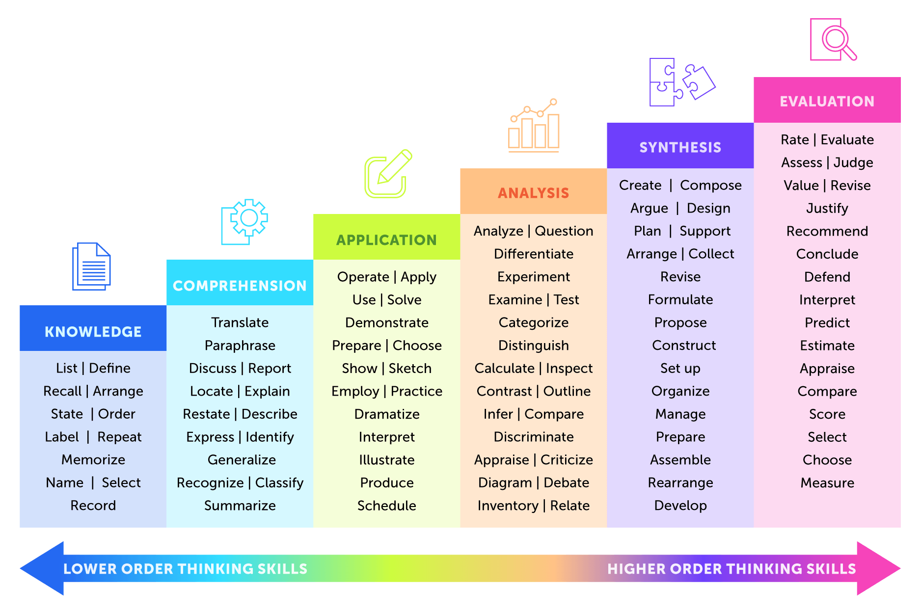

Demonstrate your learning
Show here what you said you would be able to do if you’re successful – or show as much as you can attempt!

Check your effectiveness
Were you able to accomplish the learning you planned? Yes! No.
I was able to focus | Focus | I was not able to focus
I had everything I needed | Resources | I didn’t have books, notes, computer, etc.
I understood enough to be able to learn | Understanding | I tried but still didn’t understand
I was rocking today, or just enough | Effort | I just couldn’t. Not able to “can” today.
I knew what to do to be able to learn | Strategies | I didn’t know how to engage the material
Able to care for myself well | Wellness | Too hungry, tired, or stressed
I worked mostly without errors | Accuracy | I made numerous errors
_________________________________ | Other | __________________________________

What is your next step?
Move on to the next concept | Meet with a tutor (when?):
Return to this (when?): | Meet with a peer mentor (when?):
Visit office hours (when?): | Ask_____________________ for support
Meet with Office of Student Success staff | Gather materials: ______________________
Eat, sleep, exercise, de-stress | Other

